How do I schedule an appointment with my advisor?
Virginia Tech is excited to offer online appointment scheduling through the Navigate.
- Go to www.registrar.vt.edu/campus to learn more about the platform and launch the platform by clicking the “Launch Navigate Platform” button.
- Once in the platform you will see a screen similar to this:
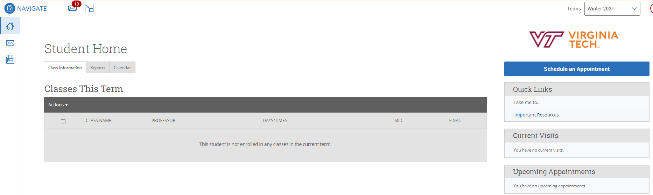
- To schedule an appointment with your advisor, click on Schedule an Appointment.
- Follow the prompts to schedule an advising appointment by first selecting Advising for What type of appointment would you like to schedule, then search for the major you want advising for under the service menu. You can leave the date as the current date or put in a future date which will of course limit your options. The click Find Available Time
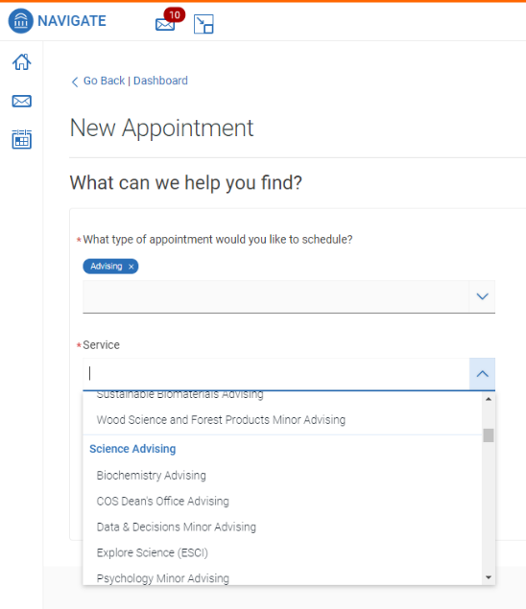

- You are then presented with the available appointment times based on the criteria you have selected. One newer feature is the option to select the modality of your appointment. Scroll down under the calendar on the left, you can select In-person or Virtual under the “How would you like to meet?”. Find the appointment time that fits your schedule by clicking the time, fill in the details for the appointment such as comments and appointment reminder information and click Schedule.
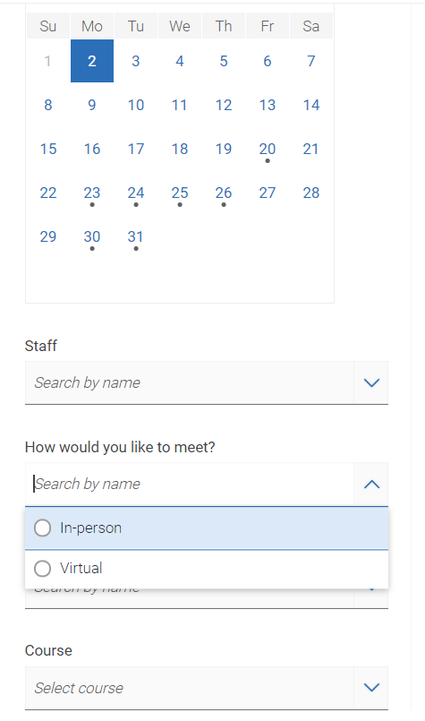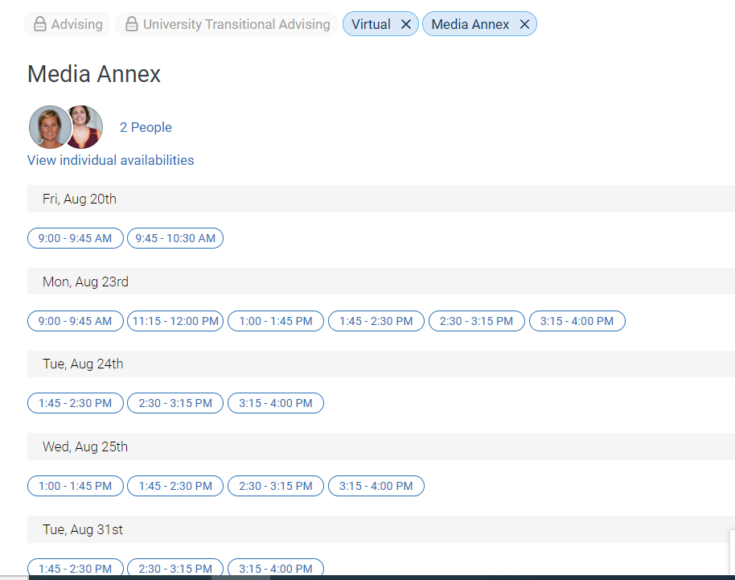
If you have no preference of modality, you can simply select the date and time of the appointment. Within the appointment you will see the modality of the appointment.
